Neuralink microchips
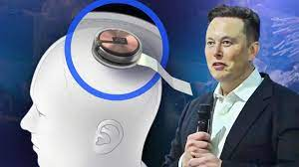

Neuralink's new technology is a small computer chip that is implanted inside the brain by a sewing machine-like robot through a network of ultra-fine wires attached to electrodes and is supposed to pick up signals from the brain and then translate them into motion control. Many in the field fantasize about using such neural interfaces to control things like prosthetics, or perhaps to interact with our devices directly. catch some of the most daring ideas; He described the Neuralink project in general that will help to communicate and live with men.
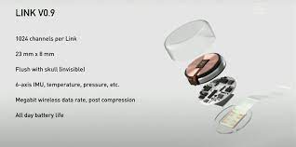

What is chip made of ?
The probes, composed mostly of polyimide, a biocompatible material, with a thin gold or platinum conductor, are inserted into the brain through an automated process performed by a surgical robot.
Can Neuralink be hacked?
Hacking is always a risk, specifically to Neuralink I believe of two types:
- Damaging it low level as a sort of mind torture device, which would likely just feel like confusion, and be much more complicated way to cause confusion than just playing loud music barney songs on repeat…
- Damaging/manipulating at very high level which is what already happens more or less with digital media designed to persuade you of one thing or another
The risk is low, but the problem is you can’t take it off, so it could be valuable to hack and even certain bugs could be quite unpleasant.

Uses:
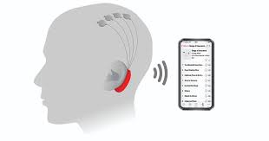

1- This chip can read all of the brain's activities, as well as the chemicals, making it able to plan and predict a person's functions.
2- The area in which the slide is implanted allows treating some hearing and vision problems as well as some psychological problems, and it is also possible in the future to treat many diseases related to nerves.
3- Through this chip, you can communicate with smartphones, computers, and others.
Pros:
1- You'll learn to never give-up on yourself.
2- He's got a nice initiative called "Neuralink" and "Tesla", especially Neuralink which if everything goes right will help remove unemployment & depression thereby, making our current planet earth a more sustainable and habitable place.
Cons:
Currently, the main concern for Neuralink is its chip's vulnerability to hacks and malicious attacks. This particular problem will be a massive cause of concern for its users and the company because of 'digital death.' The problem would bring great harm to the person, primarily when the chip is used for mobility; a 'digital death' would render the person disable and get additional injuries.

There are other factors, the most important of which are:
1- Neuralink Chip Hack
2- human vs. AI Supremacy
3- AI Take Over
4- Rise in Criminal Activities
5- Rich Supremacy
The first three are most likely and possible to happen. Technology is unpredictable, and different sinister forces such as hackers and thieves lurk in the online world. Neuralink's technology relies mostly on the internet and its services. The internet is full of dangers, ranging from content to stakeholders who are more adept and skillful in the world wide web.
Team Members

1- Ahmed elsayed farouk
2- Ebram Rasmy
3- Abanoub merzik shenouda khilla
4- Ebtisam Sayed Mahfouz
5- Ahmed Abd Elzaher Ahmed
6- Ahlam Reda Abd Elmonim

